Indy R2000 Module Series

Specification V1.1

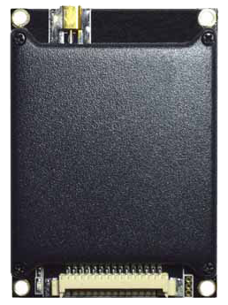

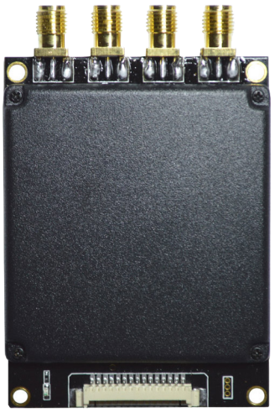

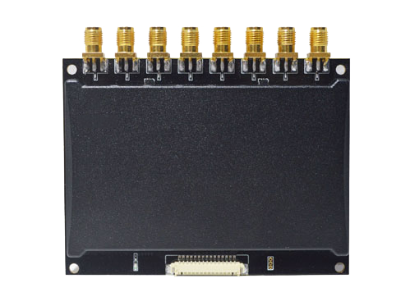

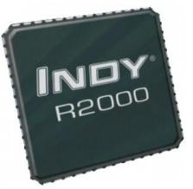

1. **Product View**

|  |  |  |  |
| --- | --- | --- | --- |
| **Module Type** | M–2600 | M-2800 | M-2900 |
| **Real Photo** |  | m-2800 |  |
| **RF Channel** | Single Channel | Four channels | Eight channels |
| **RF Connector** | MMCX | SMA | SMA |
| **Antenna Connection Mode** | Single Antenna | Four Antennas | Eight Antennas |
| **Interface Connector** | Molex 53261-1571 | | |
| **RF Connectors Material** | Gold-plated brass | | |
| **PCB Material** | Rogers FR4 gold-plated | | |
| **Shield Material** | Aluminum | | |

1. **PIN Connector Pin Assignments**

|  |  |  |
| --- | --- | --- |
|  | | |
| **PIN ID** | **Interface** | **Instruction** |
| **PIN 1** | GND | Meanwhile grounding |
| **PIN 2** | GND |
| **PIN 3** | 3.7V – 5V DC | Meanwhile connect power |
| **PIN 4** | 3.7V – 5V DC |
| **PIN 5** | GPIO 3 | Output |
| **PIN 6** | GPIO 4 | Output |
| **PIN 7** | GPIO 1 | Input |
| **PIN 8** | Beeper | Has driven with > 50mA output current |
| **PIN 9** | UART_RXD | TTL level |
| **PIN 10** | UART_TXD |
| **PIN 11** | USB_DM | For testing |
| **PIN 12** | USB_DP |
| **PIN 13** | GPIO 2 | Input |
| **PIN 14** | EN | High level enable |
| **PIN 15** | GPIO 5 | RS-485 direction control |

1. **Key Features**

|  |  |  |
| --- | --- | --- |
|  | **Feature** | **Descriptions** |
| **1** | Impinj R2000 Built-in | * Impinj Indy R2000 chip as RF transceiver. |
| **2** | Anti-collision Algorithm | * Unique I - Search multi-tag identification algorithm providing the highest efficiency. |
| **3** | Optimized Algorithm for Tags with Small Volume | * Optimized applications for reading small volume tags with better respond time. |
| **4** | Dual CPU Architecture | * Main CPU: tag inventory; Assistant CPU: data management.  * Tag inventory and data transfer are parallel and simultaneous. |
| **5** | Fast Antenna Switch Inventory (For M-2800 and M-2900) | * Every antenna’s inventory duration is configurable (Minimum duration: 30 ms).  * Polling from ANT 1 to the last antenna. |
| **6** | Two Modes for Inventory | * Buffer mode and Real-time mode.  * Tags will be stored as buffer under buffer mode.  * Tags will send data under real-time mode. This mode allows user to get tag data instantly. |
| **7** | Hardware System Halt Detection | * Hardware CPU status surveillance.  * Run for 24hours X 365 days without system halt. |
| **8** | PA Health Surveillance | * PA status surveillance.  * Make sure PA never works under saturated state. Protect it for long term operation. |
| **9** | 18000-6B/6C Full Compatible | * It can be switched rapidly between 18000-6B and 18000-6C tag. |
| **10** | 18000-6B Large Data Read/Write | * Read 216 bytes in one time takes less than 500ms.  * Write 216 bytes in one time takes less than 3.5 seconds.  * It can read/write data with different lengths. |
| **11** | Antenna Connection Detection | * Detect antenna connection status.  * Protective for RF receiver.  * It can be canceled by command. |
| **12** | Temperature Sensor | * Multi-point surveillance for accurate operating system temperature. |
| **13** | Power Output Correction | * Dual modules making sure output power can be finely adjusted.  * Dual modules working and keeping correction unless they are both damaged. |
| **14** | Excellent Cooling Design | * Heat dissipation and large cooling surface design.  * Thermal coupling interfaces using high-thermal conductivity solid materials which ensure stable performance under high temperature. |

1. **Evaluation Kit**

**M-2600 Evaluation Kit**

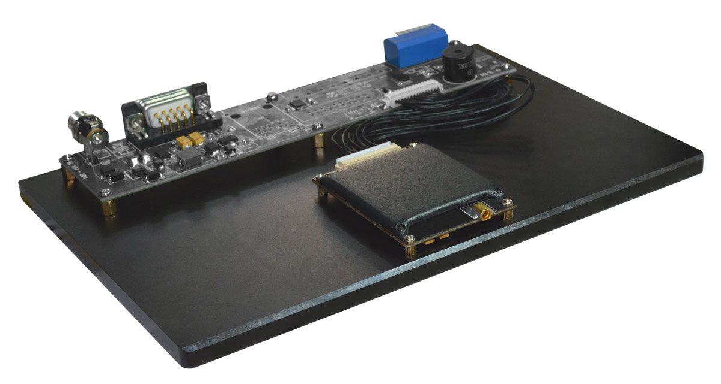

Figure 4-1: M-2600 Evaluation Kit front view

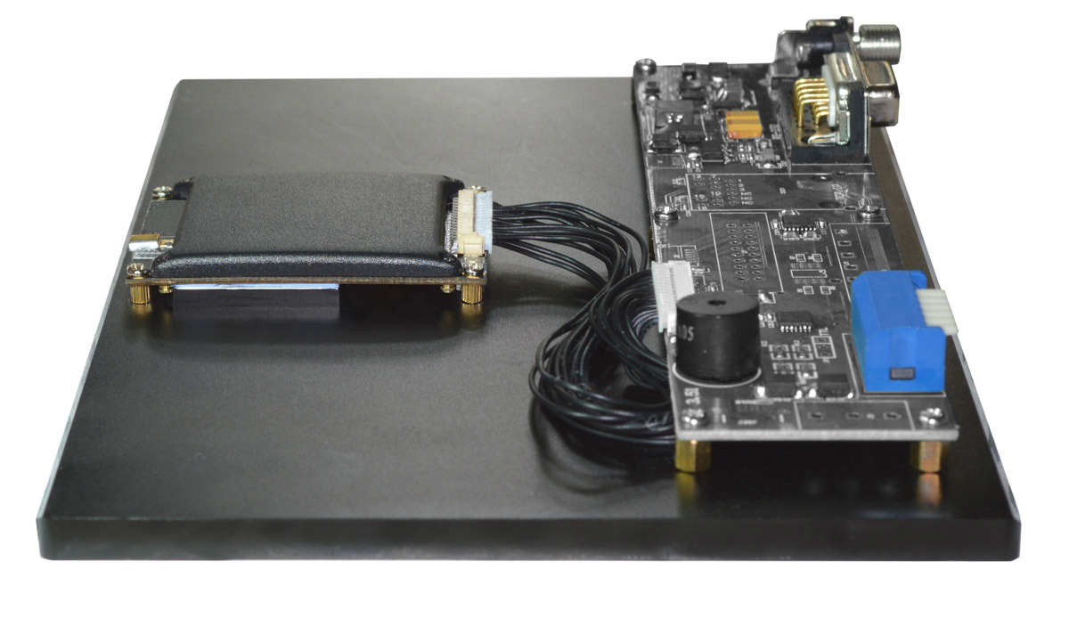Figure 4-2: M-2600 Evaluation Kit side view

**M-2800 Evaluation Kit**

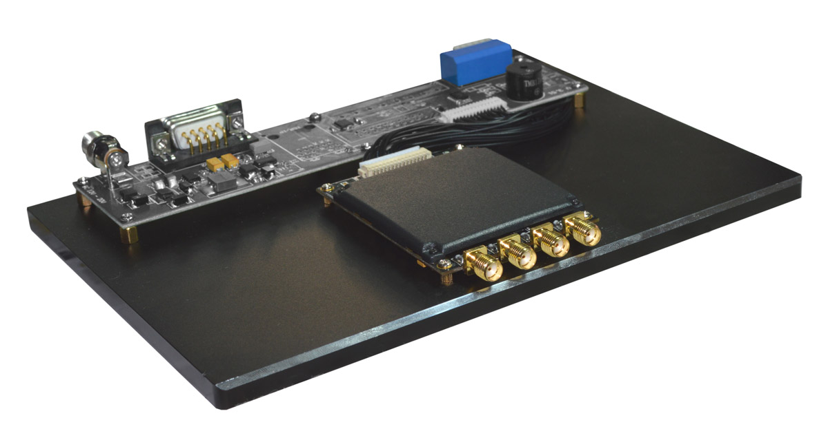

Figure 4-3: M-2800 Evaluation Kit front view

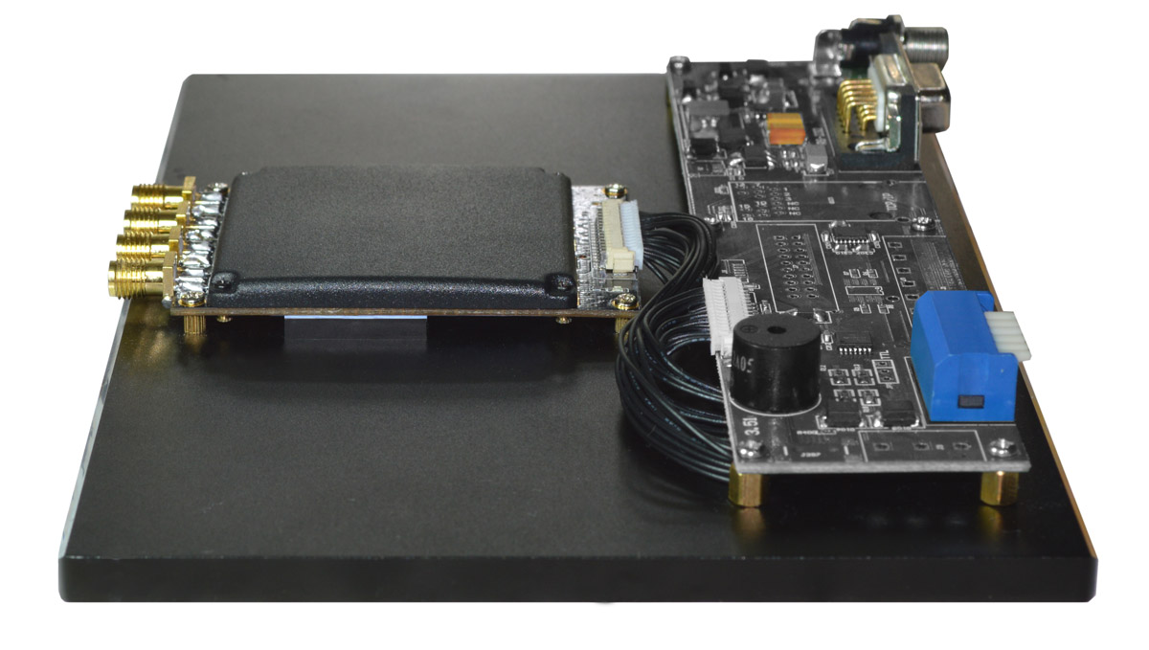

Figure 4-4: M-2800 Evaluation Kit side view

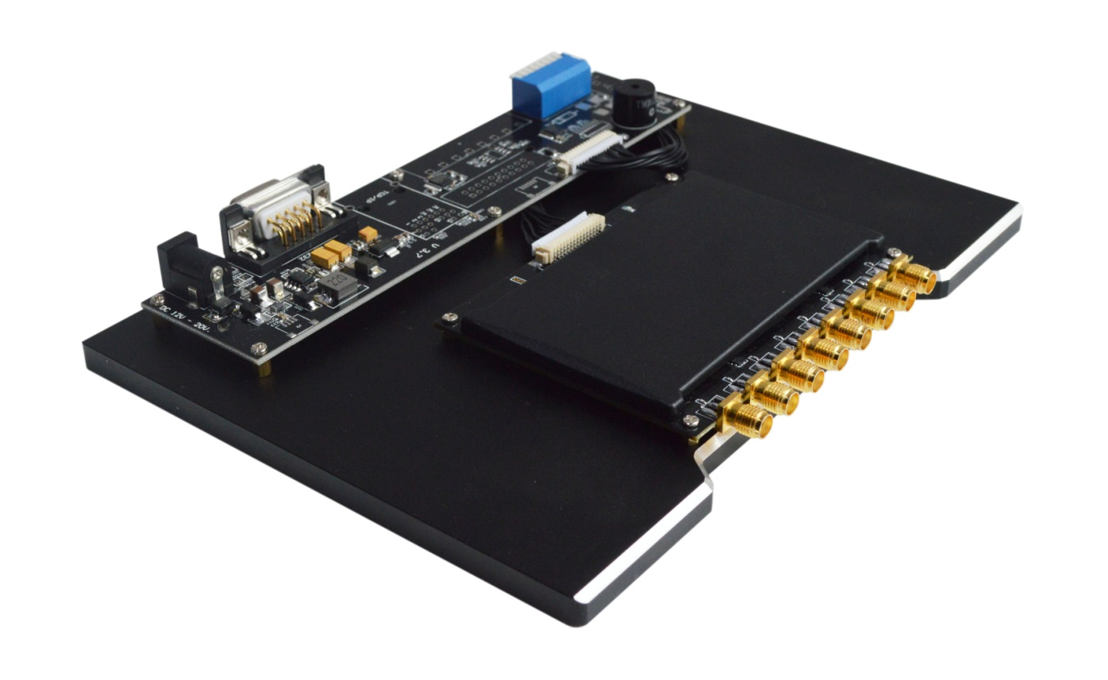**M-2900 Evaluation Kit**

Figure 4-5: M-2900 Evaluation Kit front view

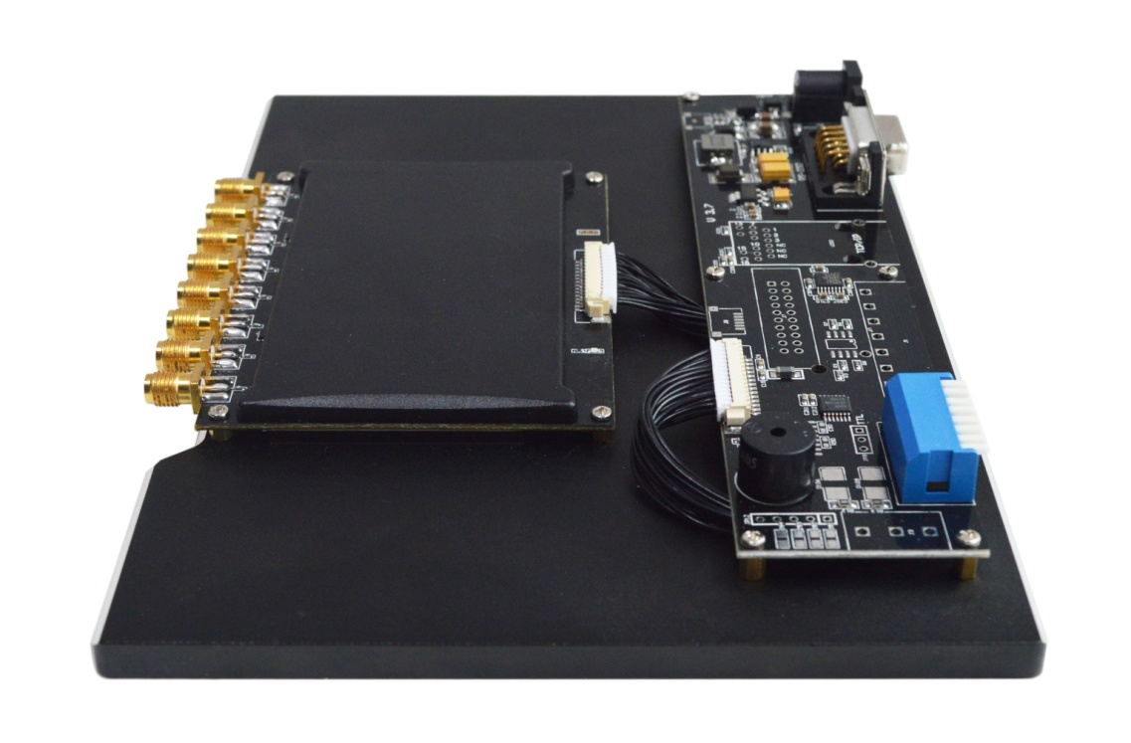Figure 4-6: M-2900 Evaluation Kit side view

1. 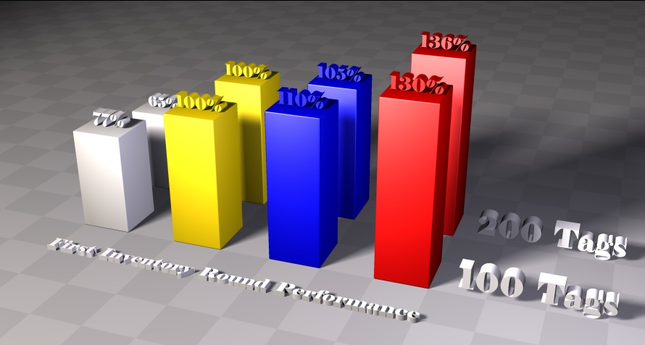**Anti-Collision Algorithm Comparison**

|  |  |  |
| --- | --- | --- |
|  | **Algorithm** | **Description** |
|  | Standard fixed Q algorithm | * Standard 18000-6C algorithm.  * The performance is reduced significantly when tag quantity gets larger.  * The efficiency is not high when tag quantity is small. |
|  | Impinj dynamic Q algorithm | * The algorithm of Impinj.  * It has a good efficiency for various tag quantities.  * It sacrifices some performance for the sake of compatibility. |
|  | I–Search dynamic Q algorithm V1.0 | * Based on Impinj dynamic Q algorithm.  * The performance is optimized.  * It’s the algorithm for firmware version 6.6 or below. |
|  | I–Search dynamic Q algorithm V2.0 | * Based on Impinj dynamic Q algorithm.  * It’s a brand new data structure, the performance of which is significantly improved for firmware version 6.7 or above.  * The improvement of performance can be easily sensed after the first round of inventory especially when the tag volume increases. |

**Notes:**

1. ) The test is on same hardware platform in real applications (Taking Impinj dynamic Q algorithm as the reference which is marked with 100%).
2. ) The chart shows the comparison for the first round inventory performance.
3. ) It is tested on the same hardware platform.
4. **Electrical Characteristics**

|  |  |
| --- | --- |
| **Operating Voltage** | 3.7V – 5 V |
| **Standby Mode Current** | <50mA (EN high level) |
| **Sleep Mode Current** | <100uA (EN low level) |
| **Max Operating Current** | 1.2A +/-10%, 600mA +/-10% (Low-power Mode, few tags) |
| **Operating Temperature** | - 20°C ~ +55°C |
| **Storage Temperature** | - 20°C ~ +85°C |
| **Humidity** | < 95% (+25°C) |
| **Air Interface Protocol** | EPC global UHF Class 1 Gen 2 / ISO 18000-6C / ISO 18000-6B |
| **Spectrum Range** | 860Mhz – 960Mhz |
| **Supported Regions** | US, Canada and other regions following U.S. FCC  Europe and other regions following ETSI EN 302 208  Mainland China  Japan  Korea  Malaysia  Taiwan |
| **Output Power** | 0 – 33dBm |
| **Output Power Precision** | +/-1dB |
| **Output Power Flatness** | +/-0.2dB |
| **Receive Sensitivity** | < -85 dBm |
| **Peak Inventory Speed** | > 700 tags/sec |
| **Tag Buffer Capacity** | 1000 tags @ 96 bit EPC |
| **Tag RSSI** | Supported |
| **Antenna Detector** | Supported |
| **Ambient Temp Monitor** | Supported |
| **Working Mode** | Single/DRM |
| **Host Communication** | TTL Uart port |
| **GPIO** | 2 inputs & 2 outputs |
| **Max Baud Rate** | 115200 bps |
| **Heat Dissipation** | Air cooling |

**Note:**

◆ When the temperature, measured by the ambient temperature measurement function, exceeds 60°C, please do not keep the device working at full capacity.

◆ Please connect the device to heat sink when it continuously work at full load.

◆ Supply voltage must not exceed 5V, otherwise it will damage the internal protection circuit.

◆ Be cautious if set RF output power over 30dBm, as the peak current and internal temperature will increase significantly.

1. **Product Dimensions**

**M-2600 Structure Dimensions**

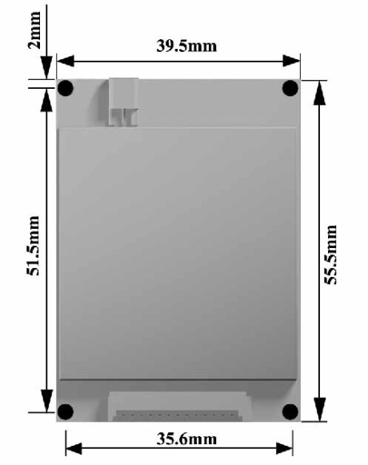

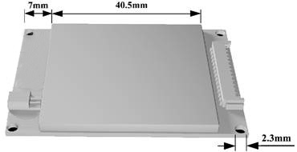

Figure 7-1: Contour and hole location Figure 7-2: Mounting hole diameter

and shield location

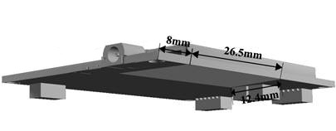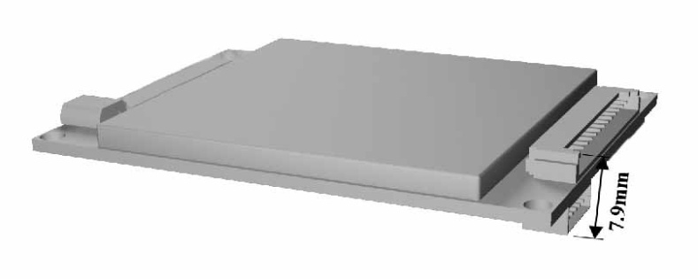

Figure 7-3: Highest point and lowest point Figure 7-4: Radiator mounting location

**M-2800 Structure Dimensions**

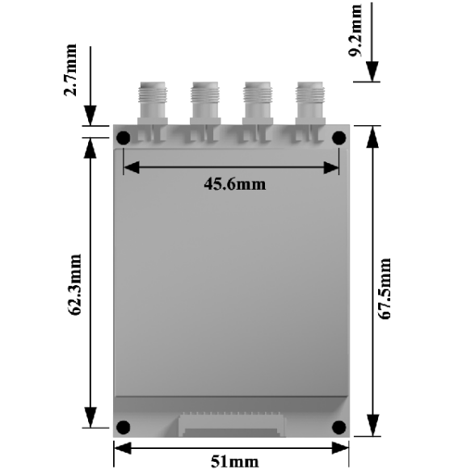

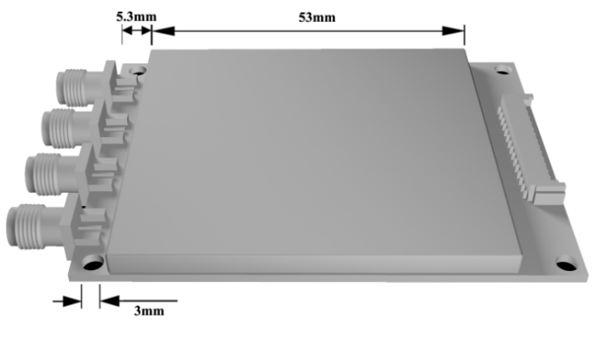

Figure 7-5: Contour and hole location Figure 7-6: Mounting hole diameter

and shield location

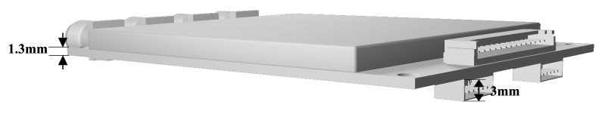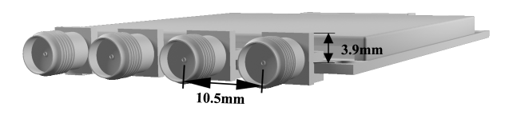

Figure 7-7: Space between highest point Figure 7-8: Thickness between lowest point

and RF connector and PCB

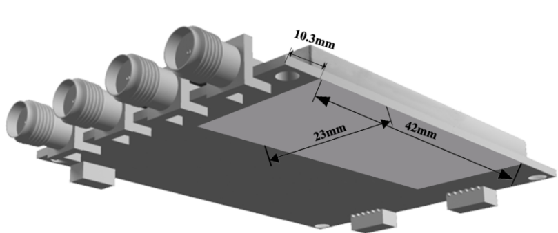

Figure 7-9: Radiator mounting location

**M-2900 Structure Dimensions**

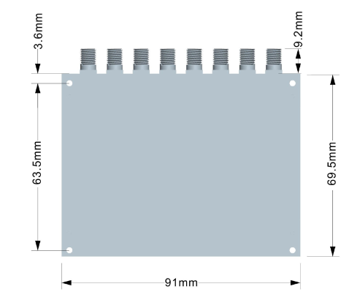

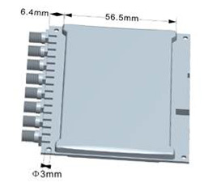

Figure 7-10: Contour and hole location Figure 7-11: Mounting hole diameter

and shield location

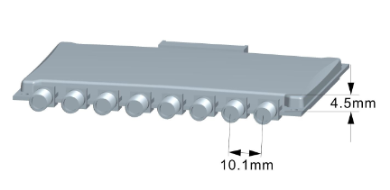

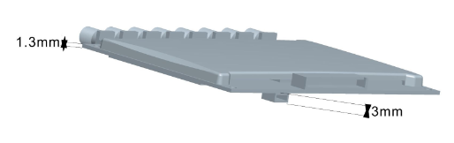

Figure 7-12: Spacing between highest point Figure 7-13: Thickness between lowest

and RF connector point and PCB

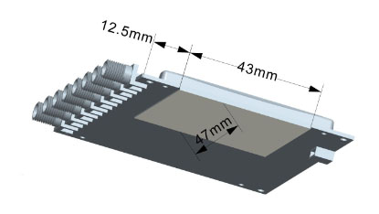

Figure 7-14: Radiator mounting location

Note

◆ Figure 7-1 to 7-14 are three-dimensional renderings, non-physical.

◆ Any discrepancy, please defer to the real product instead.